单兵辅助系统接口文档

Web端在线地址：<https://jk.mywind.com.cn/assistant/login>

用户名/密码： zhangzaiyong/123456

# 一 首页

## 1.1 设备情况

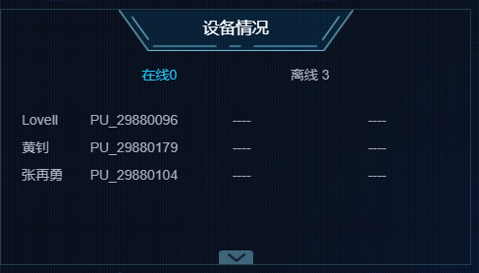

* 接口地址：https://jk.mywind.com.cn/assistantapi/api/service/ds/getDeviceInfoList
* 请求方式：GET
* 描述：获取设备列表
* 参数：

|  |  |  |  |
| --- | --- | --- | --- |
| 参数名称 | 描述 | 是否必选 | 默认值 |
| departmentId | 部门ID | 是 | 18d |
| loginUserId | 登录用户ID | 是 | 41 |

* 返回数据：

{

"message": "",

"records": {

"total": 3,

"line": 0,

"deviceList": [

{

"isParent": "false",

"address": "",

"isExternal": 5,

"uname": "PU_29880104",

"line": 0,

"displayName": "张再勇",

"pId": "18d",

"type": 0,

"name": "PU_29880104",

"pType": "5",

"id": "3054",

"DevNo": "PU_29880104",

"sn": "29880104"

}

]

},

"succ": true

}

## 1.2 作业状态

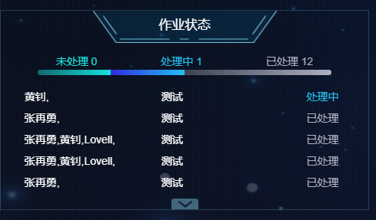

* 接口地址：https://jk.mywind.com.cn/assistantapi/api/service/ds/getDeviceInfoList
* 请求方式：POST
* 描述：获取作业状态列表
* 请求参数：

{

"current": 1,

"size": 100,

"data": {

"loginUserId": "41"

}

}

* 返回数据：

{

"message": "获取成功",

"records": {

"doingCount": 1,

"doneCount": 12,

"pageBean": {

"current": 1,

"pages": 1,

"records": [

{

"createUserId": 36,

"createUserName": "黄钊",

"deviceName": "收到",

"endDate": null,

"id": 26,

"planEndDate": "2021-06-28 09:22:00",

"planStartDate": "2021-06-28 09:20:00",

"safeMeasures": "注意佩戴安全帽",

"startDate": "2021-06-28 09:17:06",

"ticketNo": "GZ1624843026239778",

"ticketStatus": 1,

"ticketType": 0,

"workAddr": "#25",

"workContent": "测试",

"workUserIds": "36,",

"workUserNames": "黄钊,"

}

],

"size": 100,

"total": 13

},

"undoCount": 0

},

"succ": true

}

## 1.3 远程支持

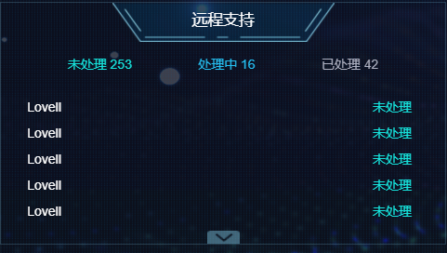

* 接口地址：https://jk.mywind.com.cn/assistantapi/api/service/support/getDataPage
* 请求方式：POST
* 描述：获取远程支持记录列表
* 请求参数：

{

"current": 1,

"size": 100,

"data": {

"loginUserId": "41"

}

}

* 返回数据：

{

"message": "获取成功",

"records": {

"doingCount": 16,

"doneCount": 42,

"pageBean": {

"current": 1,

"pages": 1,

"records": [

{

"dsSosId": "2dec41d3-fad5-4f5b-9302-0ca4b9fd9720",

"endDate": null,

"remark": "当前暂无空闲专家，请稍后再试",

"requestUserId": 31,

"requestUserName": "Lovell",

"responseUserId": null,

"responseUserName": "",

"startDate": "2021-07-07 18:33:20",

"supportContent": "",

"supportId": 744,

"supportStatus": 1,

"supportTitle": ""

}

],

"size": 500,

"total": 311

},

"undoCount": 253

},

"succ": true

}

## 1.3 告警信息

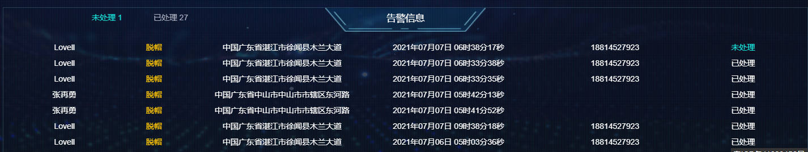

* 接口地址：https://jk.mywind.com.cn/assistantapi/api/service//tbWarnRecord/getPage
* 请求方式：POST
* 描述：获取告警记录列表
* 请求参数：

{

"current": 1,

"size": 100,

"data": {

"loginUserId": "41"

}

}

* 返回数据：

{

"message": "获取成功",

"records": {

"current": 1,

"pages": 1,

"records": [

{

"deviceId": 472,

"deviceName": "PU_29880096",

"id": 76,

"insertDate": "2021年07月07日 06时38分17秒",

"lat": 20.343789,

"lng": 110.164308,

"status": 0,

"userId": 31,

"userName": "Lovell",

"userPhone": "18814527923",

"warnAddr": "中国广东省湛江市徐闻县木兰大道",

"warnName": "脱帽",

"warnType": 2

}

],

"size": 100,

"total": 28

},

"succ": true

}

# 二 视频监控

## 2.1 设备人员列表

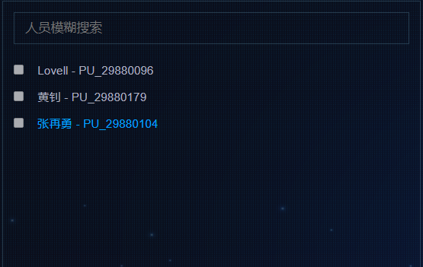

同1.1

# 三 任务管理

## 3.1 任务列表

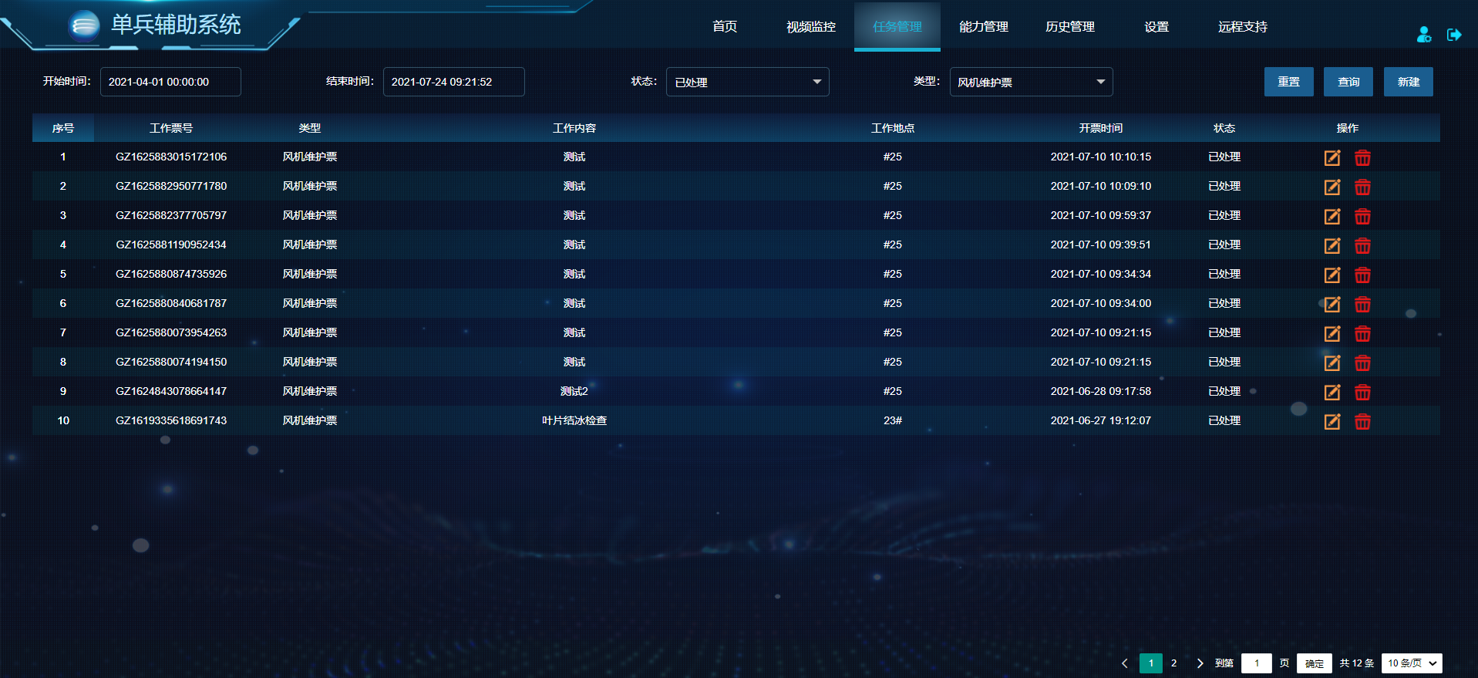

* 接口地址：https://jk.mywind.com.cn/assistantapi/api/service/workTicket/getPage
* 请求方式：POST
* 描述：获取任务列表
* 请求参数：

{

"current": 0,

"data": {

"endDate": " 2021-07-24 09:21:52",

"loginUserId": 41,

"startDate": " 2021-04-01 00:00:00",

"ticketStatus": 2,

"ticketType": 0

},

"size": 10

}

* 返回数据：

{

"message": "获取成功",

"records": {

"doingCount": 1,

"doneCount": 12,

"pageBean": {

"current": 1,

"pages": 2,

"records": [

{

"createUserId": 41,

"createUserName": "张再勇",

"deviceName": "收到",

"endDate": "2021-07-10 10:14:07",

"id": 37,

"planEndDate": "2021-07-10 10:14:07",

"planStartDate": "2021-07-10 10:13:52",

"safeMeasures": "注意佩戴安全帽",

"startDate": "2021-07-10 10:10:15",

"ticketNo": "GZ1625883015172106",

"ticketStatus": 2,

"ticketType": 0,

"workAddr": "#25",

"workContent": "测试",

"workUserIds": "41,",

"workUserNames": "张再勇,"

}

],

"size": 10,

"total": 12

},

"undoCount": 0

},

"succ": true

}

## 3.2 新建任务

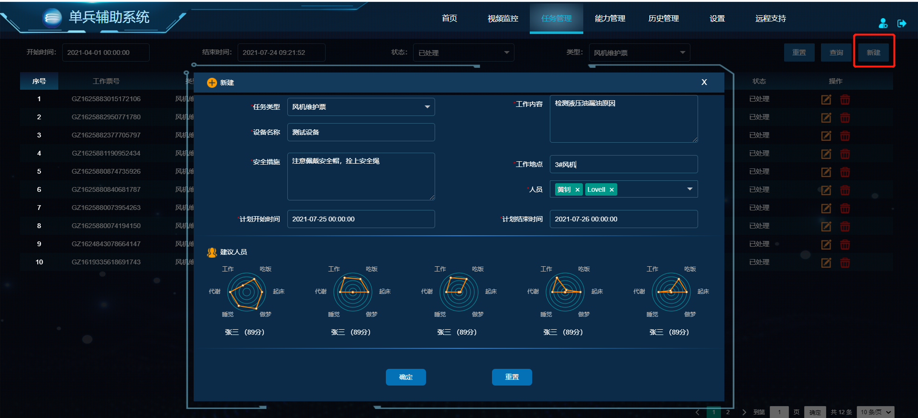

* 接口地址：https://jk.mywind.com.cn/assistantapi/api/service//workTicket/addOrUpdate
* 请求方式：POST
* 描述：添加任务
* 请求参数：

{

"createUserId": "41",

"createUserName": "张再勇",

"deviceName": "测试设备",

"id": null,

"planEndDate": "2021-07-26 00:00:00",

"planStartDate": "2021-07-25 00:00:00",

"safeMeasures": "注意佩戴安全帽，拴上安全绳",

"ticketStatus": null,

"ticketType": "0",

"workAddr": "3#风机",

"workContent": "检测液压油漏油原因",

"workUserIds": "36,31,",

"workUserNames": "黄钊,Lovell,"

}

* 返回数据：

{

"message": "添加成功",

"records": null,

"succ": true

}

## 3.3 修改任务

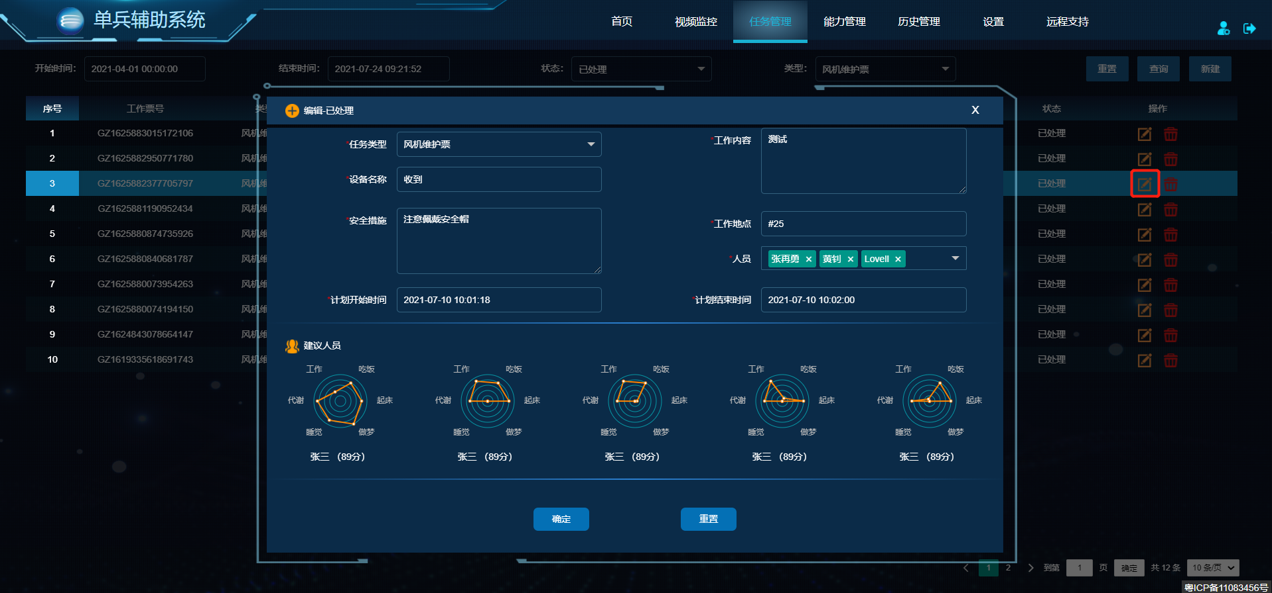

* 接口地址：https://jk.mywind.com.cn/assistantapi/api/service//workTicket/addOrUpdate
* 请求方式：POST
* 描述：修改任务
* 请求参数：

{

"createUserId": "41",

"createUserName": "张再勇",

"deviceName": "测试设备",

"id": 38,

"planEndDate": "2021-07-26 00:00:00",

"planStartDate": "2021-07-25 00:00:00",

"safeMeasures": "注意佩戴安全帽，拴上安全绳",

"ticketStatus": 0,

"ticketType": 0,

"workAddr": "3#风机",

"workContent": "检测液压油漏油原因",

"workUserIds": "36,31,",

"workUserNames": "黄钊,Lovell,"

}

* 返回数据：

{

"message": "更新成功",

"records": null,

"succ": true

}

## 3.3 删除任务

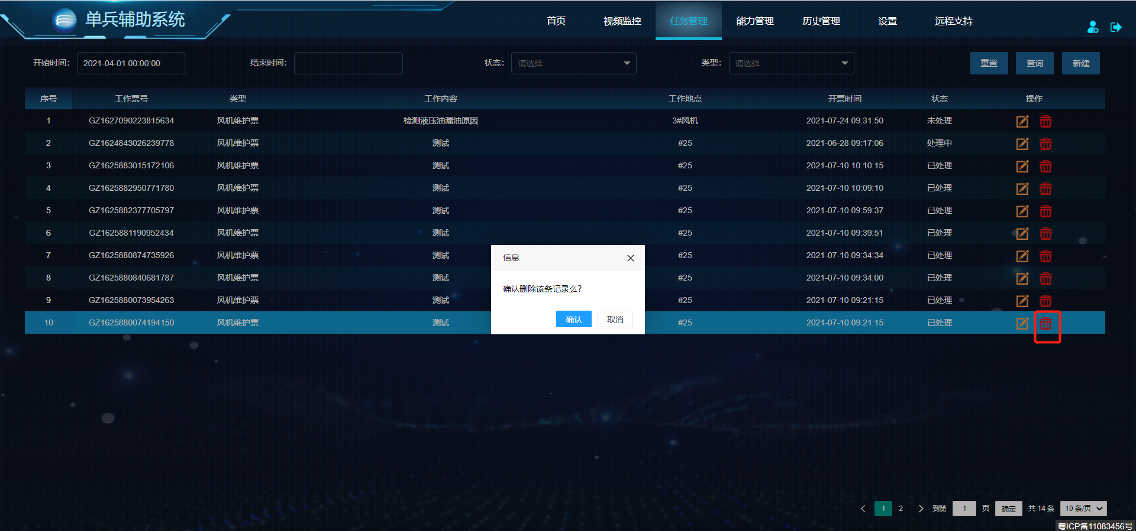

* 接口地址：https://jk.mywind.com.cn/assistantapi/api/service//workTicket/del
* 请求方式：GET
* 描述：删除任务
* 请求参数：

|  |  |  |  |
| --- | --- | --- | --- |
| 参数名称 | 描述 | 是否必选 | 默认值 |
| id | 任务ID | 是 | 30 |

* 返回数据：

{

"message": "删除成功",

"records": null,

"succ": true

}

# 四 能力管理

## 4.1 评价-培训人员列表

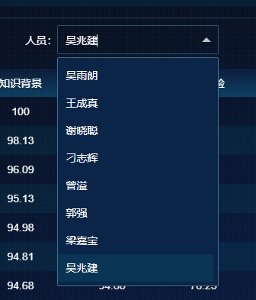

* 接口地址：https://jk.mywind.com.cn/assistantapi/api/service//ability/getAllVrUser
* 请求方式：GET
* 描述：获取培训人员列表
* 请求参数：无
* 返回数据：

{

"message": "获取步骤记录成功",

"records": [

{

"employeeNumber": "A03943",

"name": "陈德刚"

},

{

"employeeNumber": "A04023",

"name": "陈远灿"

}

],

"succ": true

}

## 4.2 评价-培训记录列表

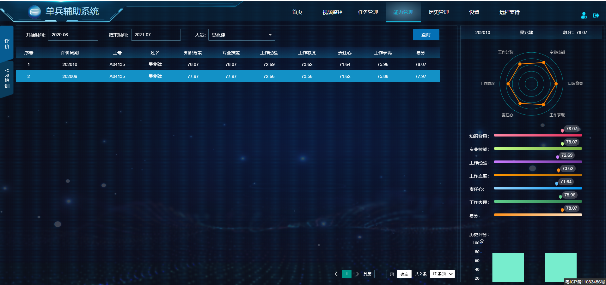

* 接口地址：https://jk.mywind.com.cn/assistantapi/api/service//ability/getGradeListData
* 请求方式：GET
* 描述：获取培训记录列表
* 请求参数：

|  |  |  |  |
| --- | --- | --- | --- |
| 参数名称 | 描述 | 是否必选 | 默认值 |
| pageIndex | 当前页 | 是 | 1 |
| pageSize | 每页大小 | 是 | 10 |
| startMonth | 开始月份 | 否 | 2020-06 |
| endMonth | 结束月份 | 否 | 2020-07 |
| employeeNumber | 工号 | 否 | A04135 |

* 返回数据：

{

"message": "获取评价结果列表成功",

"records": {

"total": 2,

"data": [

{

"area": "华南区域中心",

"conscientiousness": 71.64,

"employeeNumber": "A04135",

"id": 182,

"knowledgeBackground": 78.07,

"month": "202010",

"name": "吴兆建",

"performance": 75.96,

"professionalSkills": 78.07,

"rank": 1,

"suggestion": "需加强培训",

"total": 78.07,

"workAttitude": 73.62,

"workExperience": 72.69

}

]

},

"succ": true

}

## 4.3 评价-历史评分

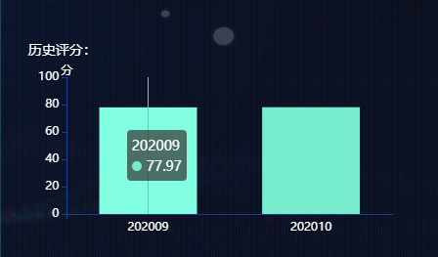

* 接口地址：https://jk.mywind.com.cn/assistantapi/api/service//ability/getHisTotalScore
* 请求方式：GET
* 描述：获取历史评分数据
* 请求参数：

|  |  |  |  |
| --- | --- | --- | --- |
| 参数名称 | 描述 | 是否必选 | 默认值 |
| employeeNumber | 工号 | 是 | A04135 |

* 返回数据：

{

"message": "获取排名图接口成功",

"records": {

"score": [

77.97,

78.07

],

"month": [

"202009",

"202010"

]

},

"succ": true

}

## 4.4 VR培训-总览

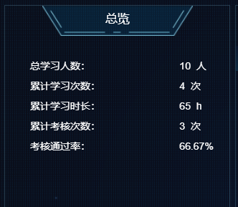

* 接口地址：https://jk.mywind.com.cn/assistantapi/api/service//ability/getOverviewData
* 请求方式：GET
* 描述：获取概览数据
* 请求参数：无
* 返回数据：

{

"message": "获取概览数据成功",

"records": {

"checkCounts": 3,

"checkRate": 66.67,

"studentNum": 10,

"trainCounts": 4,

"trainHours": 65

},

"succ": true

}

## 4.5 VR培训-排行榜

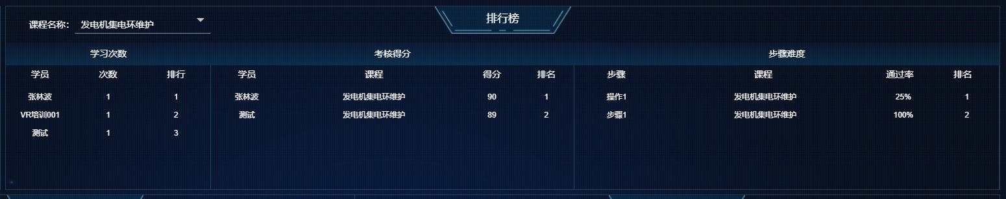

* 接口地址：https://jk.mywind.com.cn/assistantapi/api/service//ability/getTopData
* 请求方式：GET
* 描述：获取排行榜数据
* 请求参数：

|  |  |  |  |
| --- | --- | --- | --- |
| 参数名称 | 描述 | 是否必选 | 默认值 |
| courseId | 课程ID | 否 | 1 |

* 返回数据：

{

"message": "获取数据排行榜接口成功",

"records": {

"checkTopList": [

{

"courseName": "发电机集电环维护",

"orderNum": 1,

"score": 90,

"studentName": "张林波"

},

{

"courseName": "发电机集电环维护",

"orderNum": 2,

"score": 89,

"studentName": "测试"

}

],

"stepTopList": [

{

"courseName": "发电机集电环维护",

"orderNum": 1,

"passRate": 25,

"stepName": "操作1"

},

{

"courseName": "发电机集电环维护",

"orderNum": 2,

"passRate": 100,

"stepName": "步骤1"

}

],

"trainTopList": [

{

"counts": 1,

"orderNum": 1,

"studentName": "张林波"

},

{

"counts": 1,

"orderNum": 2,

"studentName": "VR培训001"

},

{

"counts": 1,

"orderNum": 3,

"studentName": "测试"

}

]

},

"succ": true

}

## 4.6 VR培训-分布-热度

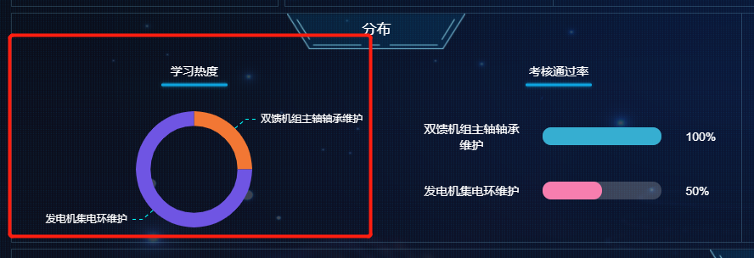

* 接口地址：https://jk.mywind.com.cn/assistantapi/api/service//ability/getCourseHotData
* 请求方式：GET
* 描述：获取热度分布数据
* 请求参数：无
* 返回数据：

{

"message": "获取课程热度分布成功",

"records": [

{

"courseName": "双馈机组主轴轴承维护",

"hotRate": 25

},

{

"courseName": "发电机集电环维护",

"hotRate": 75

}

],

"succ": true

}

## 4.7 VR培训-分布-考核通过率

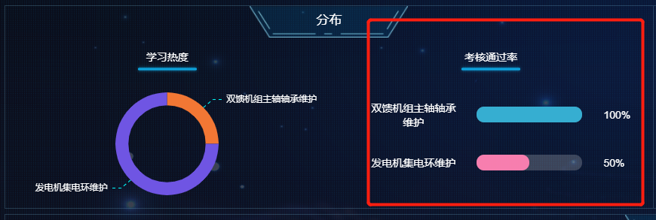

* 接口地址：https://jk.mywind.com.cn/assistantapi/api/service//ability/getCoursePassRateData
* 请求方式：GET
* 描述：获取考核通过率数据
* 请求参数：无
* 返回数据：

{

"message": "获取考核通过率对比成功",

"records": [

{

"courseName": "双馈机组主轴轴承维护",

"passRate": 1

},

{

"courseName": "发电机集电环维护",

"passRate": 0.5

}

],

"succ": true

}

## 4.8 VR培训-历史

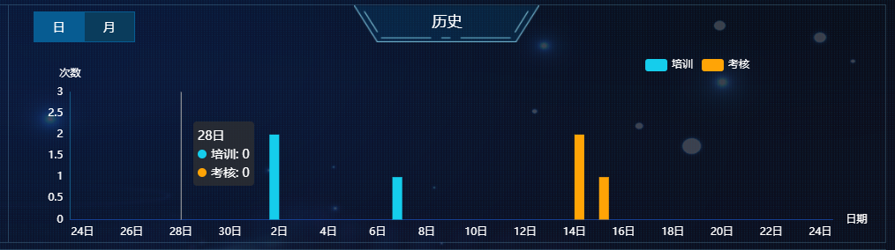

* 接口地址：https://jk.mywind.com.cn/assistantapi/api/service//ability/getTrendData
* 请求方式：GET
* 描述：获取参与次数趋势数据
* 请求参数：

|  |  |  |  |
| --- | --- | --- | --- |
| 参数名称 | 描述 | 是否必选 | 默认值 |
| type | 类型：1日、2月 | 是 | 1 |

* 返回数据：

{

"message": "获取参与次数趋势成功",

"records": [

{

"checkTimes": 0,

"time": "24",

"trainTimes": 0

},

{

"checkTimes": 0,

"time": "25",

"trainTimes": 0

}

],

"succ": true

}

## 4.9 VR培训-记录

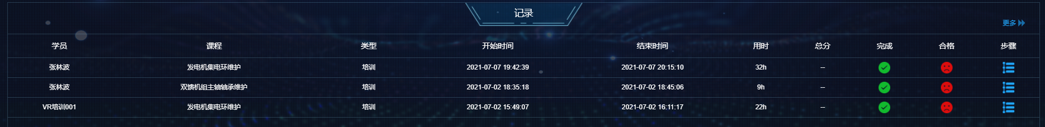

* 接口地址：https://jk.mywind.com.cn/assistantapi/api/service//ability/getHisRecordData
* 请求方式：GET
* 描述：获取课程记录数据
* 请求参数：无
* 返回数据：

{

"message": "获取课程记录成功",

"records": [

{

"courseId": 1,

"courseName": "发电机集电环维护",

"endTime": "2021-07-07 20:15:10",

"id": 3,

"isComplete": "1",

"isPass": "--",

"longTime": 32,

"score": "--",

"startTime": "2021-07-07 19:42:39",

"studentName": "张林波",

"type": "1"

}

],

"succ": true

}

## 4.10 VR培训-步骤记录

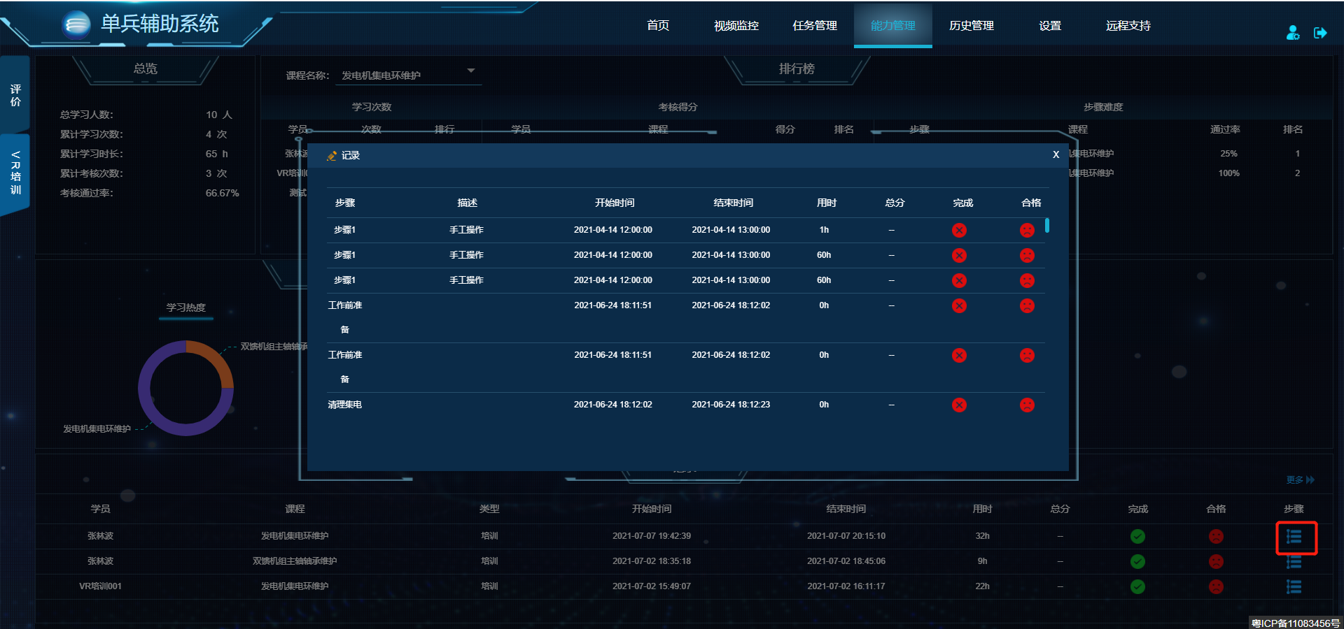

* 接口地址：https://jk.mywind.com.cn/assistantapi/api/service//ability/getStepRecordData
* 请求方式：GET
* 描述：获取步骤记录数据
* 请求参数：

|  |  |  |  |
| --- | --- | --- | --- |
| 参数名称 | 描述 | 是否必选 | 默认值 |
| id | 培训或考核记录ID | 是 | 3 |
| type | 类型 1：培训 2：考核 | 是 | 1 |

* 返回数据：

{

"message": "获取步骤记录成功",

"records": [

{

"endTime": "2021-04-14 13:00:00",

"id": 3,

"isComplete": "--",

"isPass": "--",

"longTime": 1,

"score": "--",

"startTime": "2021-04-14 12:00:00",

"stepDesc": "手工操作",

"stepName": "步骤1",

"type": "1"

}

],

"succ": true

}

## 4.11 VR培训-更多-记录

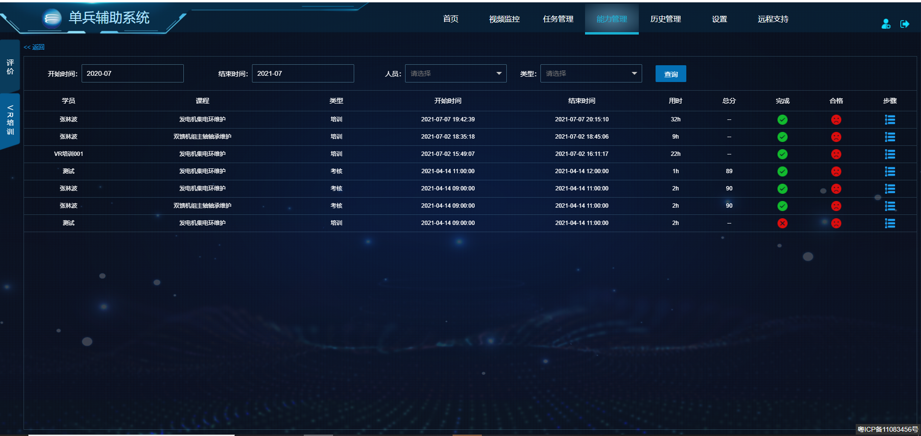

* 接口地址：https://jk.mywind.com.cn/assistantapi/api/service//ability/getHisRecordData
* 请求方式：GET
* 描述：获取更多记录数据
* 请求参数：

|  |  |  |  |
| --- | --- | --- | --- |
| 参数名称 | 描述 | 是否必选 | 默认值 |
| type | 类型 1：培训 2：考核 | 否 | 2 |
| studentName | 学员姓名 | 否 | 张林波 |
| startTime | 开始时间 | 否 | 2020-06 |
| endTime | 结束时间 | 否 | 2020-07 |

* 返回数据：

{

"message": "获取课程记录成功",

"records": [

{

"courseId": 1,

"courseName": "发电机集电环维护",

"endTime": "2021-07-07 20:15:10",

"id": 3,

"isComplete": "1",

"isPass": "--",

"longTime": 32,

"score": "--",

"startTime": "2021-07-07 19:42:39",

"studentName": "张林波",

"type": "1"

}

],

"succ": true

}

# 五 历史管理

## 5.1 时间轴

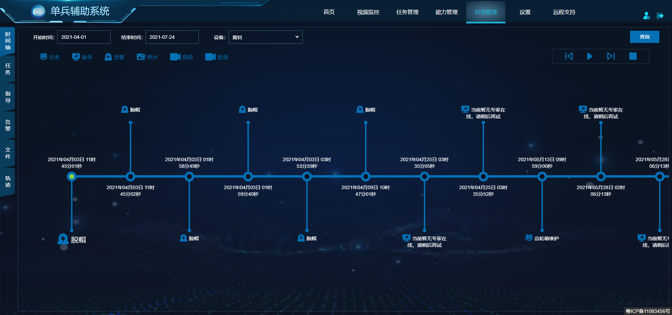

* 接口地址：https://jk.mywind.com.cn/assistantapi/api/service//timeline/get
* 请求方式：POST
* 描述：获取时间轴数据
* 请求参数：

{

"deviceUserId": "36",

"endDate": "2021-07-24",

"startDate": "2021-04-01",

"types": "0,1,2,3,4,5,"

}

* 返回数据：

{

"message": "获取成功",

"records": [

{

"content": "脱帽",

"mediaUrl": "",

"time": "2021年04月03日 11时45分01秒",

"type": 5

},

{

"content": "脱帽",

"mediaUrl": "",

"time": "2021年04月03日 11时45分02秒",

"type": 5

}

],

"succ": true

}

## 5.2 任务

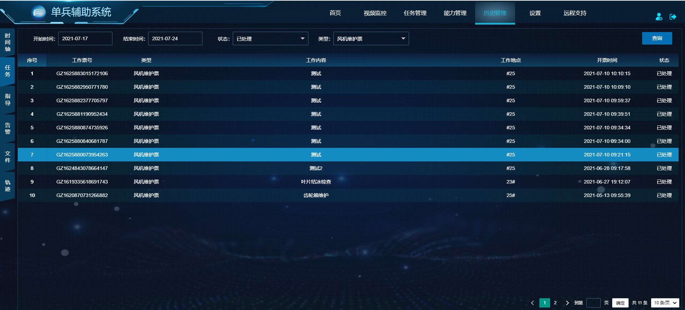

* 接口地址：https://jk.mywind.com.cn/assistantapi/api/service/workTicket/getPage
* 请求方式：POST
* 描述：获取任务列表
* 请求参数：

{

"current": 0,

"data": {

"endDate": " 2021-07-24 09:21:52",

"loginUserId": 41,

"startDate": " 2021-04-01 00:00:00",

"ticketStatus": 2,

"ticketType": 0

},

"size": 10

}

* 返回数据：

{

"message": "获取成功",

"records": {

"doingCount": 1,

"doneCount": 12,

"pageBean": {

"current": 1,

"pages": 2,

"records": [

{

"createUserId": 41,

"createUserName": "张再勇",

"deviceName": "收到",

"endDate": "2021-07-10 10:14:07",

"id": 37,

"planEndDate": "2021-07-10 10:14:07",

"planStartDate": "2021-07-10 10:13:52",

"safeMeasures": "注意佩戴安全帽",

"startDate": "2021-07-10 10:10:15",

"ticketNo": "GZ1625883015172106",

"ticketStatus": 2,

"ticketType": 0,

"workAddr": "#25",

"workContent": "测试",

"workUserIds": "41,",

"workUserNames": "张再勇,"

}

],

"size": 10,

"total": 12

},

"undoCount": 0

},

"succ": true

}

## 5.3 指导

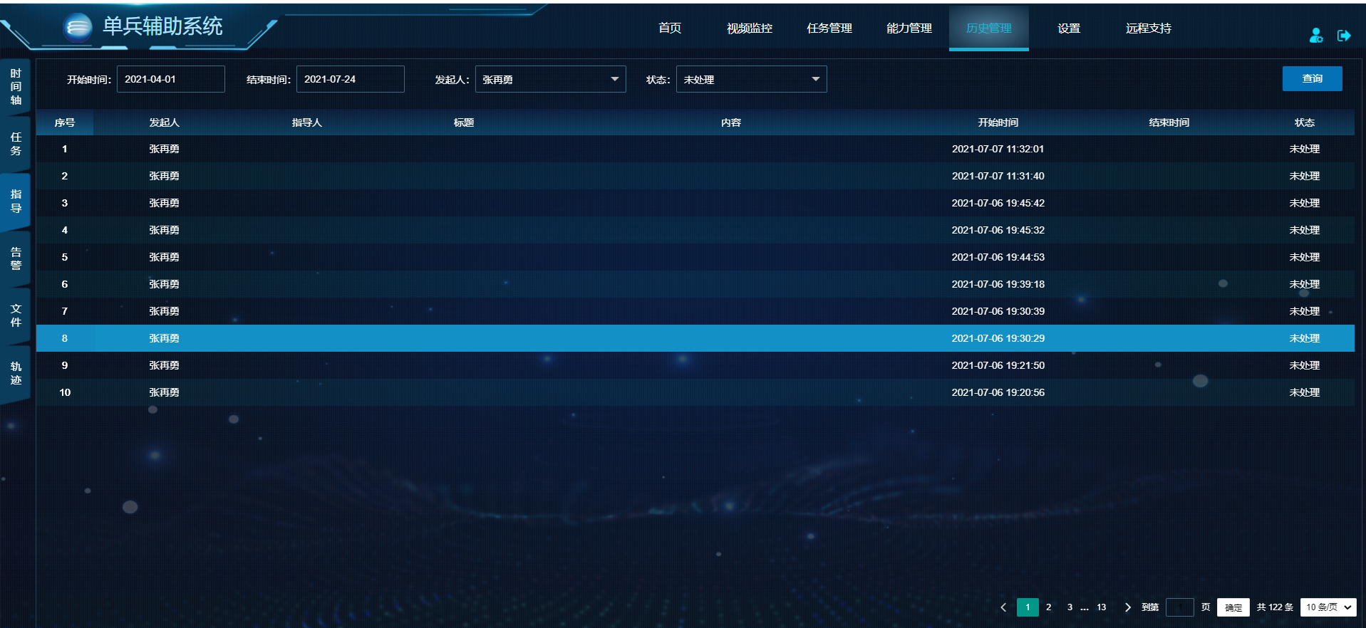

* 接口地址：https://jk.mywind.com.cn/assistantapi/api/service//support/getDataPage
* 请求方式：POST
* 描述：获取远程指导记录列表
* 请求参数：

{

"current": 1,

"data": {

"endDate": "2021-07-24 11:18:40",

"loginUserId": "41",

"requestUserId": "41",

"responseUserId": null,

"startDate": "2021-04-01 08:00:00",

"status": "1"

},

"size": 10

}

* 返回数据：

{

"message": "获取成功",

"records": {

"doingCount": 16,

"doneCount": 42,

"pageBean": {

"current": 1,

"pages": 13,

"records": [

{

"dsSosId": "0a4fb33a-c636-4964-8d33-9f7cb28ddbf3",

"endDate": null,

"remark": "当前暂无专家在线，请稍后再试",

"requestUserId": 41,

"requestUserName": "张再勇",

"responseUserId": null,

"responseUserName": "",

"startDate": "2021-07-07 11:32:01",

"supportContent": "",

"supportId": 716,

"supportStatus": 1,

"supportTitle": ""

}

],

"size": 10,

"total": 122

},

"undoCount": 253

},

"succ": true

}

## 5.4 告警

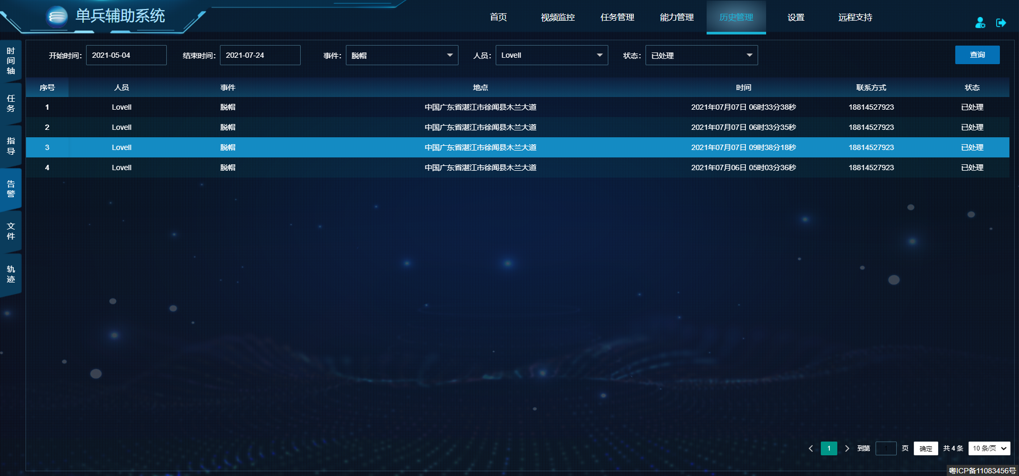

* 接口地址：https://jk.mywind.com.cn/assistantapi/api/service//tbWarnRecord/getPage
* 请求方式：POST
* 描述：获取告警记录列表
* 请求参数：

{

"begin": "2021-05-04 08:00:00",

"end": "2021-07-24 11:27:02",

"loginUserId": "41",

"pageIndex": 1,

"pageSize": 10,

"status": "1",

"userId": "31",

"warnName": "脱帽"

}

* 返回数据：

{

"message": "获取成功",

"records": {

"current": 1,

"pages": 1,

"records": [

{

"deviceId": 472,

"deviceName": "PU_29880096",

"id": 75,

"insertDate": "2021年07月07日 06时33分38秒",

"lat": 20.343789,

"lng": 110.164308,

"status": 1,

"userId": 31,

"userName": "Lovell",

"userPhone": "18814527923",

"warnAddr": "中国广东省湛江市徐闻县木兰大道",

"warnName": "脱帽",

"warnType": 2

}

],

"size": 10,

"total": 4

},

"succ": true

}

## 5.5 文件

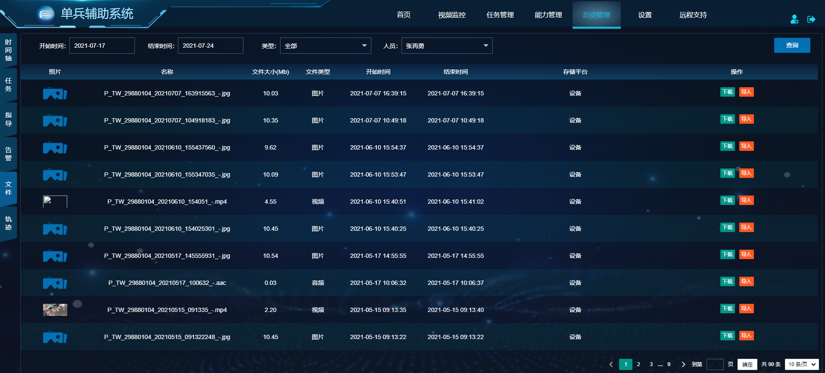

* 接口地址：https://gdvi.itecsun.com:3005/device/video/retrieve
* 请求方式：POST
* 描述：获取文件记录
* 请求参数：

{

"beginTime": "2021-07-17 18:47:22",

"endTime": "2021-07-24 18:47:22",

"pageNumber": 1,

"pageSize": 10,

"personnel": [

3054

],

"storageType": 1,

"type": 9

}

* 返回数据：

{

"status": 200,

"rows": [

{

"duration": 0,

"endTime": 1625647155563,

"id": 44,

"md5": "2A4E696365A6A6777C3942442AC019C7",

"name": "P_TW_29880104_20210707_163915563_-.jpg",

"size": 10516022,

"startTime": 1625647155563,

"storageType": 1,

"thumbType": 0,

"type": 1,

"upload": 0,

"video": "/video/play/3054/1/44",

"preview": ""

}

],

"total": 90

}

## 5.6 轨迹

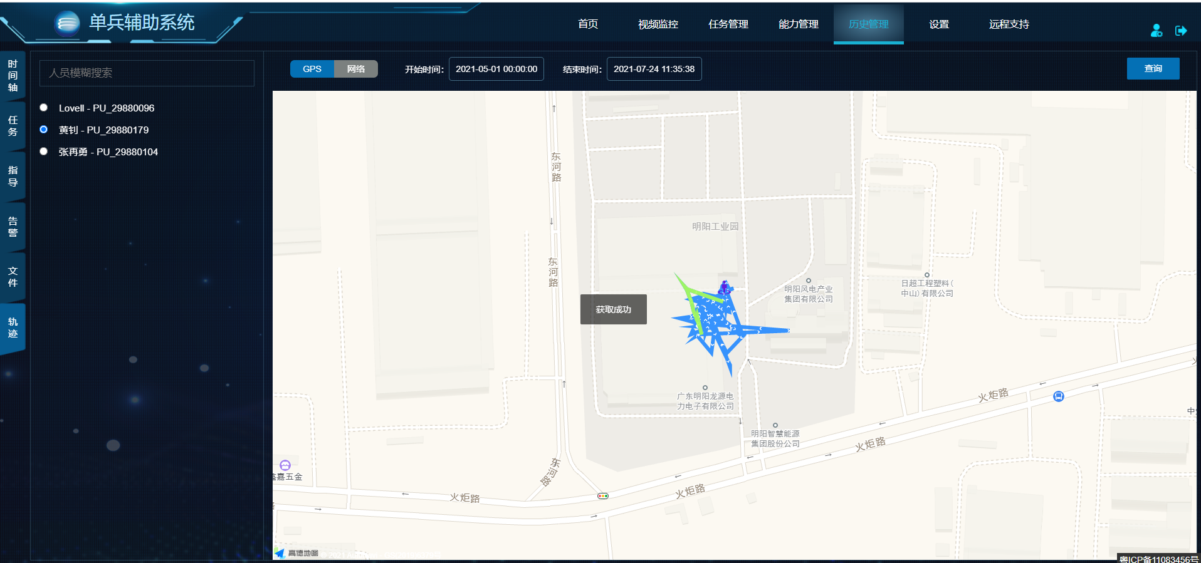

* 接口地址：https://jk.mywind.com.cn/assistantapi/api/service//ds/getTrajectory
* 请求方式：POST
* 描述：获取历史轨迹记录
* 请求参数：

{

"begin": "2021-05-01 00:00:00",

"distance": 50,

"end": "2021-07-24 11:35:38",

"gpsType": [

0

],

"personnel": "471",

"type": 1

}

* 返回数据：

{

"message": "获取成功",

"records": [

{

"lat": 22.560821,

"lng": 113.441751,

"status": 0,

"time": "2021-05-13 10:08:56",

"type": 0

},

{

"lat": 22.560977,

"lng": 113.441712,

"status": 0,

"time": "2021-05-13 10:08:58",

"type": 0

}

],

"succ": true

}

# 六 远程支持

## 6.1 机型

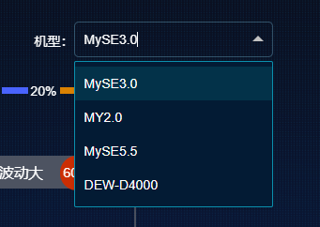

* 接口地址：https://jk.mywind.com.cn/assistantapi/api/service//faultTree/getFaultTreeModel
* 请求方式：GET
* 描述：获取机型列表
* 请求参数：无
* 返回数据：

{

"message": "获取故障字典机型数据成功",

"records": [

{

"model": "MySE3.0"

},

{

"model": "MY2.0"

},

{

"model": "MySE5.5"

},

{

"model": "DEW-D4000"

}

],

"succ": true

}

## 6.2 故障名称

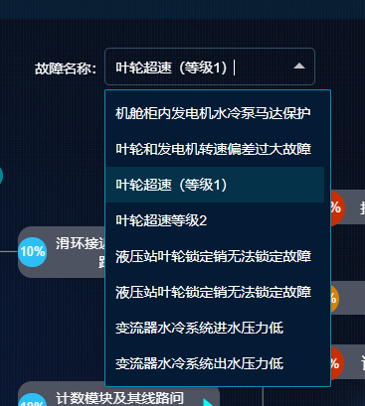

* 接口地址：https://jk.mywind.com.cn/assistantapi/api/service//faultTree/getFaultTreeName
* 请求方式：GET
* 描述：获取故障名称列表
* 请求参数：

|  |  |  |  |
| --- | --- | --- | --- |
| 参数名称 | 描述 | 是否必选 | 默认值 |
| model | 机型 | 是 | MySE3.0 |

返回数据：

{

"message": "获取故障字典故障名称成功",

"records": [

{

"nodeId": "11001",

"nodeName": "偏航速度高"

},

{

"nodeId": "11002",

"nodeName": "偏航速度低"

}

],

"succ": true

}

## 6.3 故障树

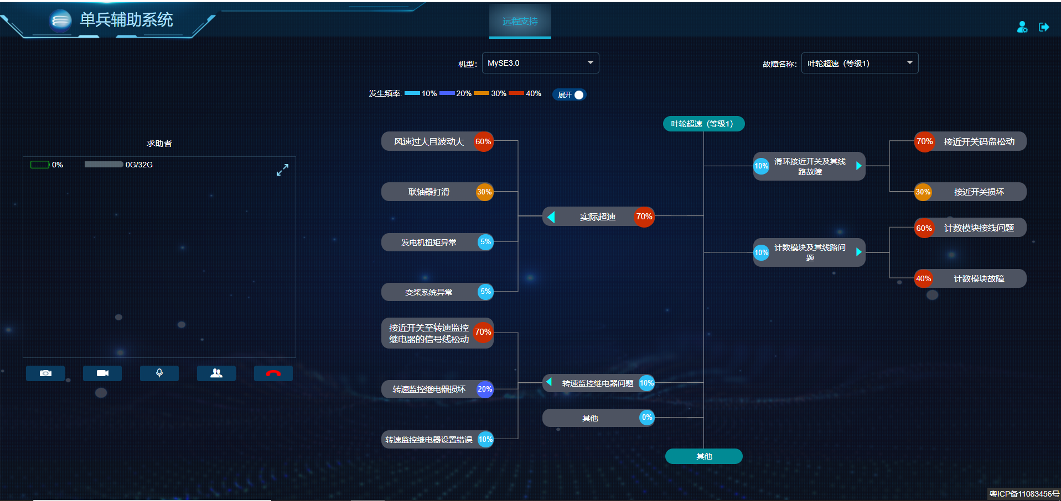

* 接口地址：https://jk.mywind.com.cn/assistantapi/api/service//faultTree/getFaultTreeInfo
* 请求方式：GET
* 描述：获取故障树数据
* 请求参数：

|  |  |  |  |
| --- | --- | --- | --- |
| 参数名称 | 描述 | 是否必选 | 默认值 |
| model | 机型 | 是 | MySE3.0 |
| nodeId | 节点ID | 是 | 14007 |

返回数据：

{

"message": "获取故障字典故障树信息成功",

"records": [

{

"comment": "",

"createTime": 1593502415000,

"faultFrequency": "",

"faultReasonPr": null,

"faultReasonPr2": null,

"id": 10177,

"judgeMethods": "叶轮转速超过16.8rpm，持续2秒触发“SC_叶轮超速（等级1）”故障（叶轮直径112m和121m），延时两秒触发故障。\n叶轮转速超过15.4rpm，持续2秒触发“SC_叶轮超速（等级1）”故障（叶轮直径135m），延时两秒触发故障。\n",

"model": "MySE3.0",

"nodeDesc": "叶轮超速触发软件超速保护",

"nodeId": "14007",

"nodeName": "叶轮超速（等级1）",

"nodeParentid": "",

"nodeType": "1",

"nodeTypeDesc": "根节点",

"processingMethods": "继续排查具体原因",

"remark": "",

"specialty": "",

"techControl": "",

"treeName": "叶轮超速（等级1）V1",

"treeType": "87"

}

],

"succ": true

}

## 6.4 填写远程支持内容

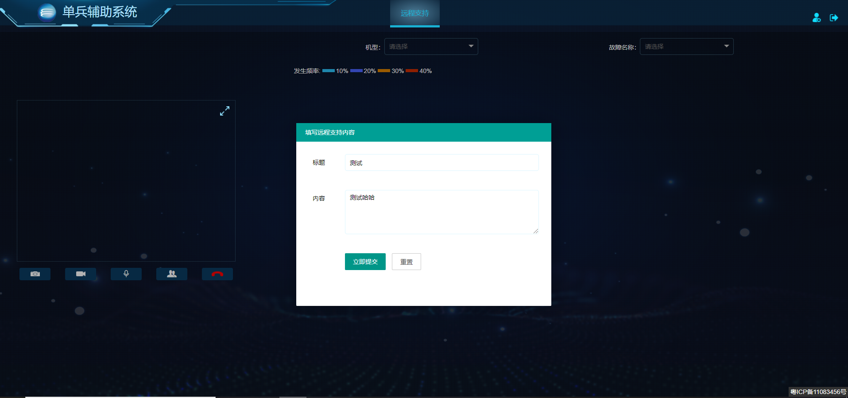

* 接口地址：https://jk.mywind.com.cn/assistantapi/api/service//support/updateContent
* 请求方式：POST
* 描述：填写远程支持内容
* 请求参数：

{

"sosId": "df37a7c2-a443-45a7-a769-5dbbe13b6023",

"title": "测试",

"content": "测试哈哈",

"loginUserId": 50

}

* 返回数据：

{

"message": "更新成功",

"records": null,

"succ": true

}